

Game Design Document

for a VR Escape Room

Escape room

2025/05/18

Su XiangLing

Confidential Disclaimer
This Game Design Document has been prepared for review by Su XiangLing. All information is confidential and proprietary and should not be shared without written permission.

Overview of the Game
Genre: Puzzle / VR Escape Room
You awaken in a moonlit classical Chinese garden—a place of tranquil ponds, winding pathways, and pavilions adorned with crimson lanterns. But this sanctuary is a gilded cage. Legend says the garden’s creator sealed a priceless treasure here, guarded by poetic riddles, shifting symbols, and the spirits of nature itself. To escape, you must harmonize with the garden’s soul—before its eternal night claims you forever.

Unique Selling Points
Sensory Wonder: The scent of plum blossoms, the glow of silk lanterns, the sound of guqin melodies—every detail pulls you deeper.
Easy to play

Game loop
- Enter the garden
- Find the riddle
- Put the onion in the bucket to solve the puzzle
- The bridge will appear
- Find the knife to break the stones that block the moon door
- Pass the bridge to pick up the knife and break the stones to solve the puzzle
- Enter next room
- Find three red colour things put on the table to solve the puzzle
- Enter next room
- Use red colour fan to break the red colour wood
- Find the blue colour fan to break the blue colour wood to solve the puzzle
- The Tai Chi graphics and the winning text will appear

Story Board
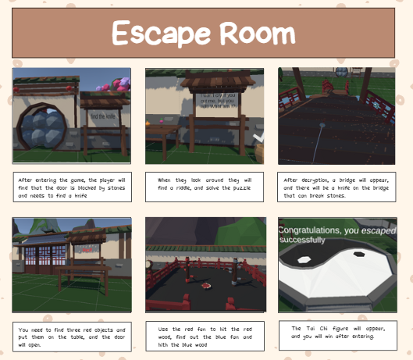

Gameplay Scope
- How long is the game? What is the average playtime?
Experienced players can finish the game in about 20 minutes
It takes longer for novice players to finish the game， about 40 minutes.
In average it will takes 30 mins.
- How many levels are there?
There is a total of three rooms
The first room has two puzzles
The second room has one puzzle
The third room has one puzzle and the way to win

- What are the objectives?
Simple but with a certain degree of difficulty, it allows novices to quickly fall in love with escape rooms。

How many playable characters? Can you customize or upgrade them/what can you customize or upgrade?
There are only one playable character, which is the player, cannot be upgrade.

Your considerations for the questions above should be for a VR game where there are some considerable differences from a normal 2D game.

Art Style
Chinese ancient style


Game Design Mockup
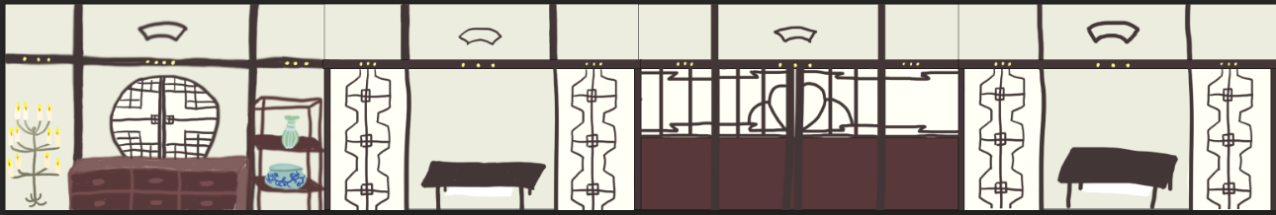

Player Profiles Stories
Basic Info
- Name: Lily
- Age: 20
- Occupation: Student

Game Interests
- Gaming style: escape room
- Hours spent gaming weekly: 9h
- Gaming platform(s): Oculus Rift, Playstation + PSVR, PC
- Favorite game(s): Escape, Find Way Out
- Favorite game genre(s): Mystery, Puzzle

Entertainment Interests
- Favorite movie(s): Fengshen Bang, Nezha
- Social media platforms: Instagram, Twitter, Reddit

Likes: Figuring things out, taking their time with games.
Dislikes: Repetitive, being challenged, Competitive gaming

Milestone Schedule
Milestone | Milestone Description | Done By
1 | Game Design Document for a VR Escape Room | July 6, 2025
2 | Build the scene | July 15, 2025
3 | Finished first and second puzzle | July 20,2025
4 | Finished third and fourth puzzle | July 30,2025
5 | Test | July 31,2025

